**Tema 3**

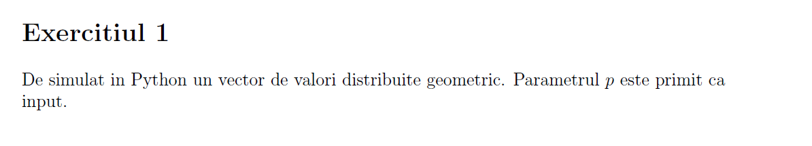

def probability_to_occur_at(attempt, p):  
 return (1-p)**(attempt-1) * p  
  
def geometric(p, N=100):  
 V = [0 for _ in range(N)]  
 val_max = 1  
 for i in range(N):  
 nr = 1 * (np.random.uniform(0, 1) < p)  
 cnt = 1  
 while nr != 1:  
 nr = 1 * (np.random.uniform(0, 1) < p)  
 cnt += 1  
 V[i] = cnt  
 if val_max < cnt:  
 val_max = cnt  
 if val_max < N + 1:  
 val_max = N + 1  
  
 # vectorul calculat frecventionist  
 F = [0 for _ in range(val_max)]  
 for i in range(val_max):  
 F[i] = V.count(i) / N  
 plt.scatter(range(N + 1), F, color='g', label='frecvential')  
  
 # compar cu valorile teoretice  
 T = [0 for _ in range(val_max)]  
 for i in range(val_max):  
 T[i] = probability_to_occur_at(i, p)  
 plt.scatter(range(N + 1), T, color='y', label='teoretical pmf')  
  
 plt.legend()  
 plt.show()  
  
def main():  
 p = float(input("Introduceti p = "))  
 geometric(p)

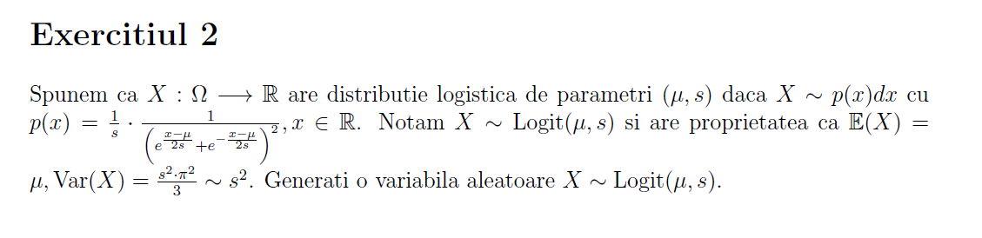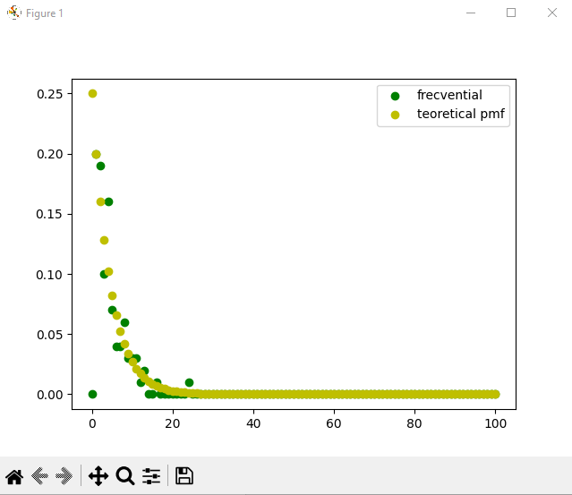Pentru p = 0.2 si N=100 a fost generat urmatorul grafic:

import numpy as np  
import matplotlib.pyplot as plt  
from math import e  
import math  
  
  
def count_in_interval(arr, left_lim, right_lim):  
 ctr = 0  
 for x in arr:  
 if x >= left_lim and x <= right_lim:  
 ctr += 1  
 return ctr  
  
  
def count_smaller(arr, left_lim):  
 ctr = 0  
 for x in arr:  
 if x <= left_lim:  
 ctr += 1  
 return ctr  
  
  
def Logistic(u, s, N):  
 uniform_array = []  
 for i in range(N):  
 uniform_array.append(np.random.uniform(0, 1))  
  
 log_x = np.log(uniform_array)  
 uniform_array = [1-x for x in uniform_array]  
 log_1_x = np.log(uniform_array)  
 log_simulated = [u + s * (log_x[i] - log_1_x[i]) for i in range(N)]  
 return log_simulated  
  
  
def see_pdf(u, s, simulated_values, bins_number):  
 x_bins = np.linspace(0, 10, bins_number)  
  
 actual_pdf = []  
 for i in range(len(x_bins) - 1):  
 actual_pdf.append(1/(s*((math.pow(e, (x_bins[i] - u)/(2*s)) + math.pow(e, (-1)*(x_bins[i] - u)/(2*s))))**2))  
  
 distribution = []  
 for i in range(len(x_bins) - 1):  
 ctr = count_in_interval(simulated_values, x_bins[i], x_bins[i + 1])  
 distribution.append(ctr / len(simulated_values))  
  
 fig, ax = plt.subplots(1, 1)  
 ax.scatter(x_bins[:-1], actual_pdf, color='pink', label='built-in pdf', alpha=1)  
 ax.scatter(x_bins[:-1], distribution, color='cyan', label='simulated pdf', alpha=0.5)  
  
  
def see_cdf(u, s, simulated_values, bins_number):  
 x_bins = np.linspace(0, 10, bins_number)  
  
 actual_cdf = []  
 for i in range(len(x_bins) - 1):  
 actual_cdf.append(1/(1+(math.pow(e, (-1)*(x_bins[i] - u)/s))))  
  
 distribution = []  
 for i in range(len(x_bins) - 1):  
 ctr = count_smaller(simulated_values, x_bins[i])  
 distribution.append(ctr / len(simulated_values))  
  
 fig, ax = plt.subplots(1, 1)  
 ax.scatter(x_bins[:-1], actual_cdf, color='pink', label='built-in pdf', alpha=1)  
 ax.scatter(x_bins[:-1], distribution, color='cyan', label='simulated pdf', alpha=0.3)  
  
def main():  
 u = 5  
 s = 2  
 N = 10000  
 bins_number = 100  
 simulated_values = Logistic(u, s, N)  
 see_pdf(u, s, simulated_values, bins_number)  
 see_cdf(u, s, simulated_values, bins_number)  
 plt.show()  
  
if __name__ == "__main__":  
 main()

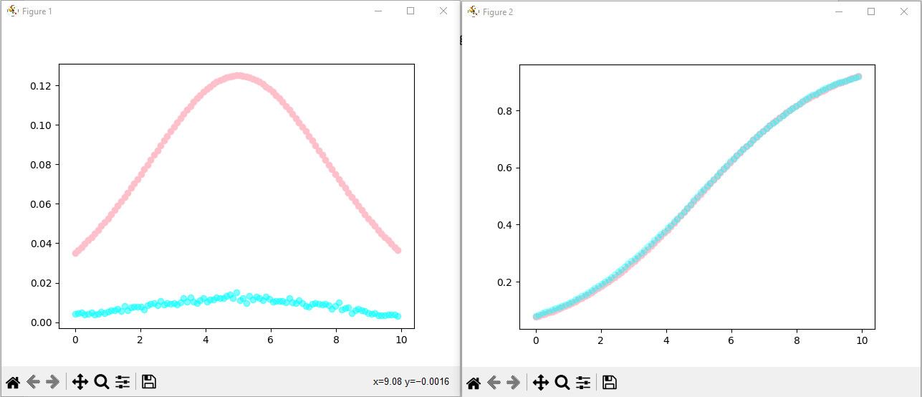 Pentru u = 5, s = 2 si N=10000 au fost generate urmatorele grafice: